Regulations:
A14

H.T No

Sreenidhi Institute of Science and Technology
(An Autonomous Institution)
Code No: 4AC07 Date: 16-Dec-2019 (AN)

B.Tech IV-Year I-Semester External Examination, December - 2019 (Supplementary)
CONTROL SYSTEMS (ECE)

Time: 3 Hours Max.Marks:70

Note: a) No additional answer sheets will be provided.
b) All sub-parts of a question must be answered at one place only, otherwise it will not be valued.
c) Missing data can be assumed suitably.

Part - A Max.Marks:20

Answer all QUESTIONS.

1. | Define Transfer function. Derive an expression for the transfer function of a closed loop “positive” feedback system. | [2M]
2. | Define Rise time and Maximum overshoot and write their formula. | [2M]
3. | State the angle and magnitude condition. | [2M]
4. | Define i) Gain Cross Over Frequency.  ii) Phase Cross Over Frequency. | [2M]
5. | State basis for Nyquist Stability criterion. | [2M]
6. | List the properties of State transition Matrix. | [2M]
7. | Name and define the static error coefficients. | [2M]
8. | Define auxiliary polynomial. What is its order? | [2M]
9. | State the variables involved in Modeling of dynamic systems, in state space analysis. | [2M]
10. | State Mason’s gain Formula. | [2M]
Part – B Max.Marks:50
ANSWER ANY FIVE QUESTIONS. EACH QUESTION CARRIES 10 MARKS.

11. | a) | Define Control System. List the differences between Open loop and Closed loop Control systems. | [4M]
 | b) | Obtain , for the block diagram shown in below figure using block diagram reduction technique.  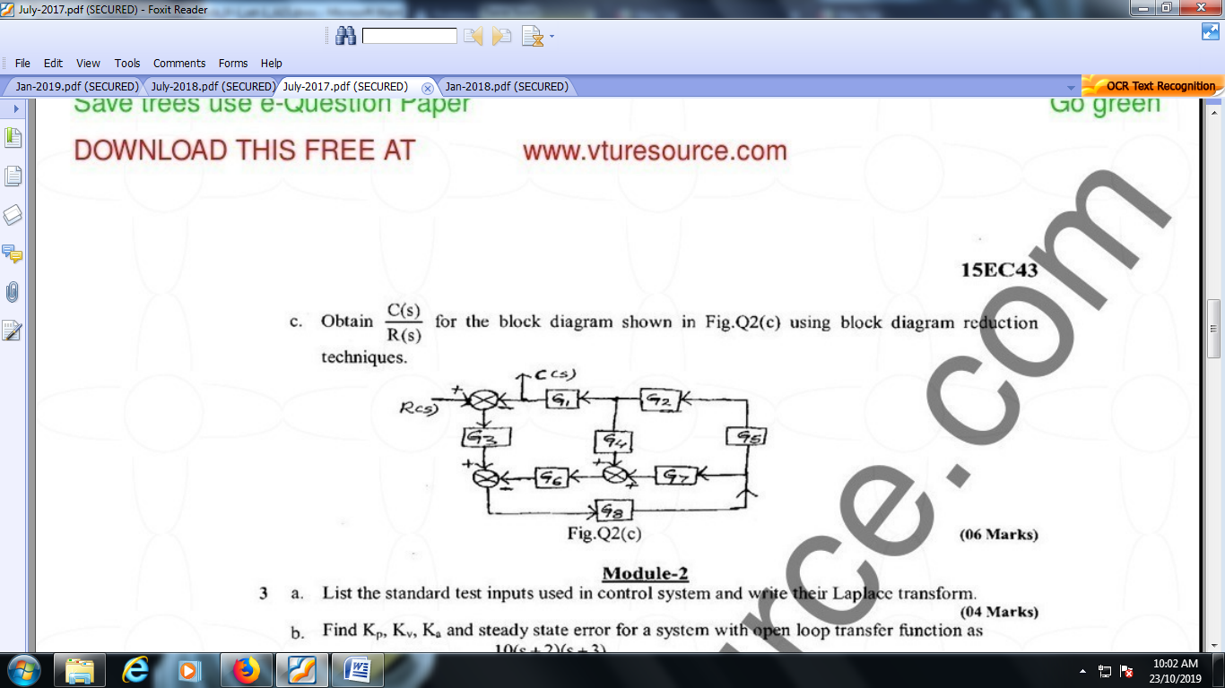 | [6M]
12. | a) | Find the step response, c(t) for the system described by . Also find time constant, rise time and settling time. | [4M]
 | b) | Find Kp, Kv, Ka and steady state error for a system with open loop transfer function as  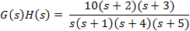  Where the input is . | [6M]
13. | a) | State and Explain Routh-Hurwitz criterion. | [4M]
 | b) | The open loop transfer function of a control system is given by  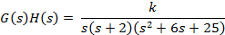  Sketch the complete root locus as ‘k’ is varied from zero to infinity. | [6M]
14. | a) | Write notes on correlation between time and frequency response of a second order system. | [4M]
 | b) | For a unity feedback system given below sketch the bode plot and find ω_{gc}, ω_{pc}, gain margin and phase margin.  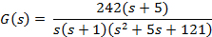 | [6M]
15. | a) | Write short notes on polar plots. | [4M]
 | b) | State and Explain Nyquist stability criterion. | [6M]
16. | a) | Derive an expression for the solution of a homogeneous state equation. | [4M]
 | b) | Obtain appropriate state model for a system represented by an electric circuit as shown in below figure.  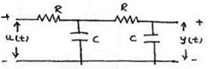 | [6M]
17. | a) | Explain the construction and working of a synchro. | [4M]
 | b) | Show that with integral controller, the steady state error is zero for a ramp input. | [3M]
 | c) | Determine the range of values of K for the stability of a unity feedback system  whose open loop transfer function is given by  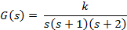 | [3M]
18. | a) | Write short notes on log magnitude versus phase plot. | [3M]
 | b) | What is the need of lead compensator? Derive its transfer function and also draw the bode plot. | [3M]
 | c) | Develop the state model of linear time invariant systems. | [4M]

-- 00 -- 00 –

